***Week 12 Coding***

***Program 1***

*You are a bank account hacker. Initially you have 1 rupee in your account, and you want exactly N rupees in your account. You wrote two hacks, first hack can multiply the amount of*

*money you own by 10, while the second can multiply it by 20. These hacks can be used any number of time. Can you achieve the desired amount N using these hacks.*

*Constraints:*

*Input*

*The test case contains a single integer N.*

*Output*

*For each test case, print a single line containing the string "1" if you can make exactly N rupees or "0" otherwise.*

*SAMPLE INPUT*

*1*

*SAMPLE OUTPUT*

*1*

*SAMPLE INPUT*

*2*

*SAMPLE OUTPUT*

*0*

***Coding***

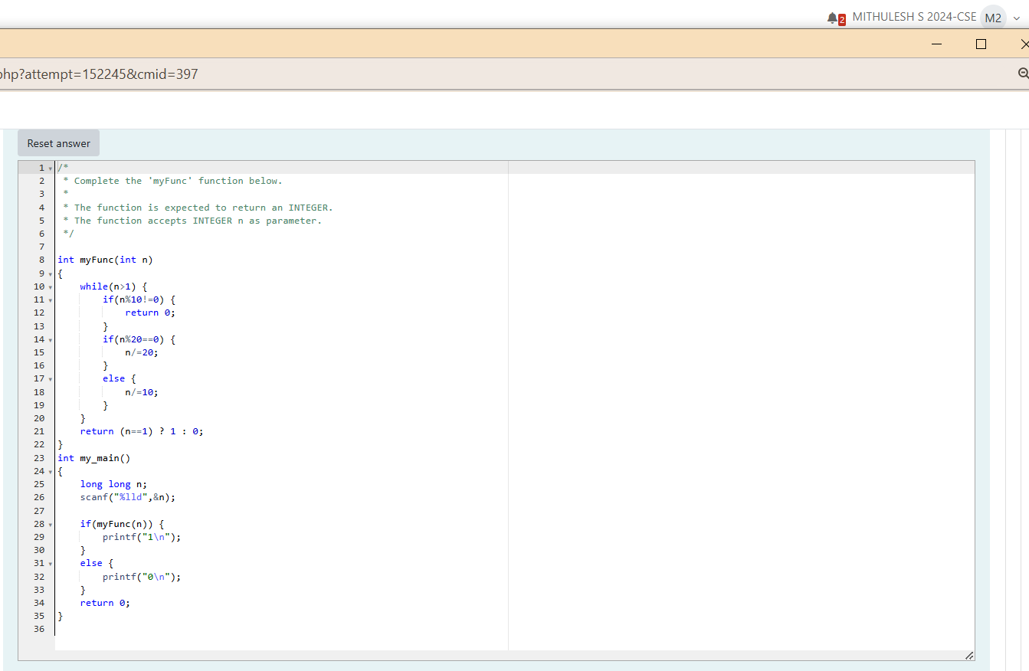

***Output***

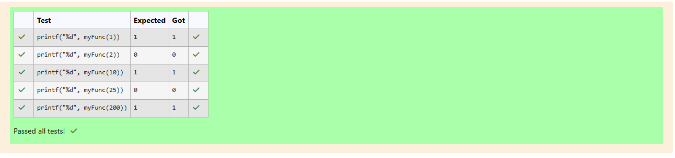

***Program 2***

*Find the number of ways that a given integer, X, can be expressed as the sum of the Nth powers of unique, natural numbers.*

*For example, if X = 13 and N = 2, we have to find all combinations of unique squares adding up to 13. The only solution is 22 + 32.*

*Function Description*

*Complete the powerSum function in the editor below. It should return an integer that represents the number of possible combinations,*

*powerSum has the following parameter(s):*

*X: the integer to sum to*

*N: the integer power to raise numbers to*

*Input Format*

*The first line contains an integer X.*

*The second line contains an integer N.*

*Constraints*

*1 s x s 1000*

*2 s N s 10*

*Output Format*

*Output a single integer, the number of possible combinations calculated.*

*Sample Input O*

*10*

*2*

*Sample Output O*

*1*

*Explanation O*

*IfX = 10 and N*

*12+32*

*= 2, we need to find the number of ways that 10 can be represented as the sum of squares of unique numbers.*

*This is the only way in which 10 can be expressed as the sum of unique squares.*

*Sample Input 1*

*100*

*2*

*Sample Output 1*

*3*

*Explanation I*

*100 = (102) = (62+82)*

*Sample Input 2*

*100*

*3*

*Sample Output 2*

*1*

*Explanation 2*

*(12 + 32 + 42 + + 72)*

*100 can be expressed as the sum of the cubes of 1, 2, 3, 4.*

*(1 + 8 + 27 + 64 = 100). There is no other way to express 100 as the sum of cubes.*

***Coding***

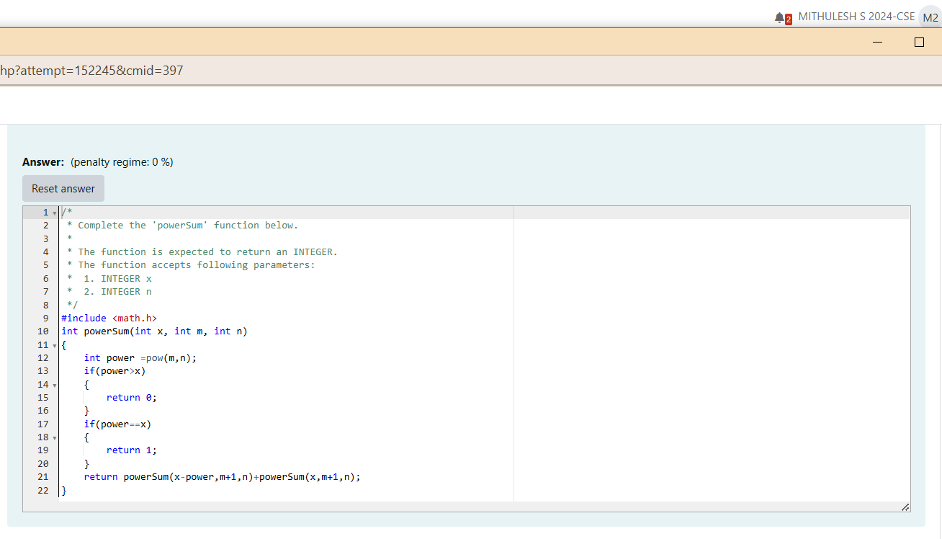

***Output***

